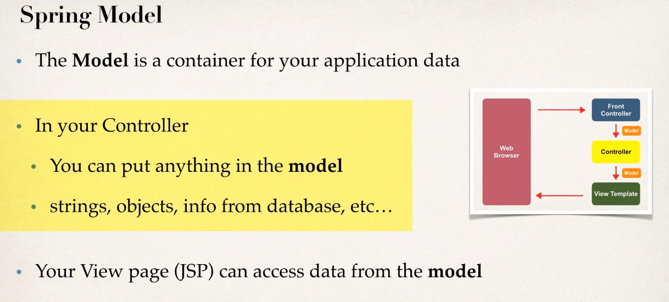

Demonstration of a simple model implementation:

1. **Passing Model to Controller**: Here we can add as many attributes in the model using addAttribute method. The first-string parameter is the name of the variable that we can use to access the data, and 2nd parameter is the actual data.

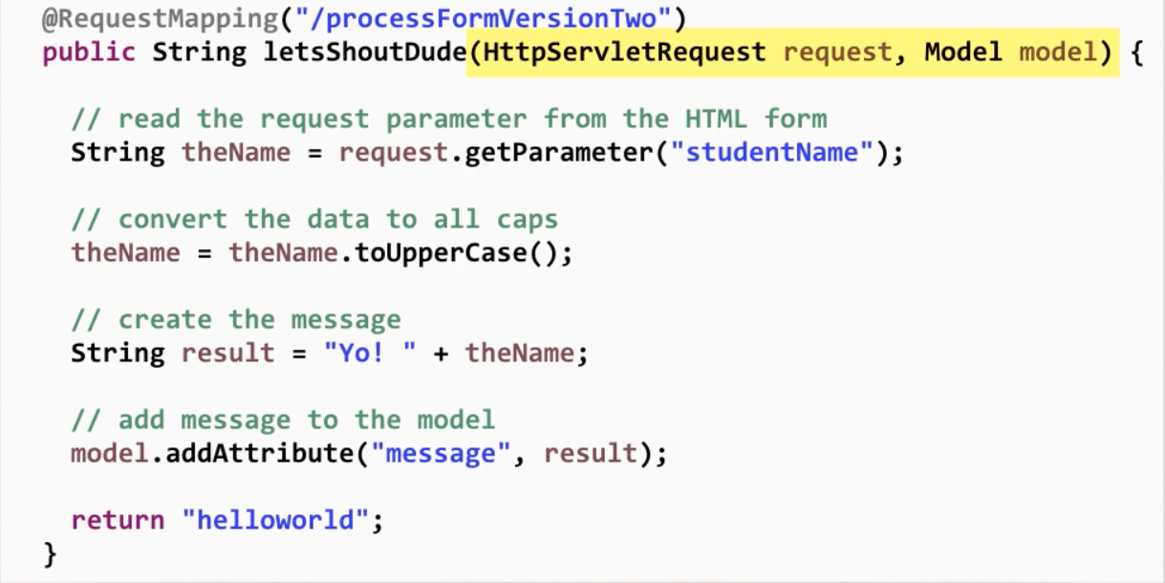

1. **View Template:** Here we can use the model data using EL.

